Kwikmart E-Com. Web Application

*A Major-project Report submitted in partial fulfillment of the requirements for the award of the degree of*

## Master of Computer Applications

By

## Shubham Gupta (18419MCA042)



**Department of Computer Science Institute of Science**

**Banaras Hindu University, Varanasi – 221005**

**2021**

## CANDIDATE’S DECLARATION

I **Shubham Gupta** hereby certify that the work, which is being presented in the Major-project report, entitled **Kwikmart E-Com. Web Application**, in partial fulfillment of the requirement for the award of the Degree of **Master of Computer Applications** and submitted to the institution is an authentic record of my/our own work carried out during the period March-2021 to July 2021 under the supervision of **Dr. Pramod Kumar Mishra**.

The matter presented in this Major-project as not been submitted elsewhere for the award of any other degree or diploma from any Institutions.



Date: 15-07-2021 Candidate Signature

The Viva-Voce examination of **Shubham Gupta**, M.C.A. Student has been held on 20 -07-2021.

Signature of the Supervisor

# Abstract

Kwikmart Web. Application is a Grocery Web based E-Com. project which aims at developing a website to ease the process of buying grocery (for customers) and for shopkeepers to manage their business. The website provide the facility of customer login/signup. This website is developed using Django Web framework, SQLite Database, HTML, CSS, Bootstrap in frontend.

The website makes it easier for the customer to view products available in the grocery store. The customer can add/remove products from the cart. The customer can place his/her order online from anywhere without having to visit the store. The customer can view his/her profile and can update his/her details. The customer can also see his/her order history. The customer can contact the grocery store for any queries and feedbacks directly from the website.

# Overall this website is developed to help store owner to manage their business online and customers to buy products online from anywhere.

# TABLE OF CONTENTS

#### INTRODUCTION

* 1. General ..........................................................................................................................
  2. Problem Description.....................................................................................................
  3. Motivation…………......................................................................................................
  4. Objective………….. .....................................................................................................

#### LITERATURE REVIEW

2.1 About the project...........................................................................................................

2.2 Goals of the proposed system .......................................................................................

2.3 Functionality .................................................................................................................

#### METHODOLOGY

3.1 Introduction...................................................................................................................

3.2 User Involved................................................................................................................

3.3 Schema Design..............................................................................................................

3.4 Project Architecture………………………………………………………………….

3.5 Technologies used…………………………………………………………………….

#### RESULTS AND ANALYSIS

4.1 Introduction...................................................................................................................

4.2 System specification .....................................................................................................

4.3 Software Interface .........................................................................................................

4.4 Performance matrix…………………………………………………………………...

4.5 Advantages…………………………………………………………………………….

4.6 Limitations…………………………………………………………………………………

* 1. Some Snapshots…………………………………………………………………………….

#### 5. CONCLUSION AND SUMMARY

5.1 Summary .......................................................................................................................

5.2 Future Work ..................................................................................................................

5.3 Conclusion ....................................................................................................................

**REFERENCES** ....................................................................................................................

# Chapter 1

**INTRODUCTION**

Online shopping is the process whereby consumers directly buy goods or services from a seller in real-time, without an intermediary service, over the Internet. It is a form of electronic commerce. An online shop, e-shop, e-store, internet shop, web shop, online store, or virtual store evokes the physical analogy of buying products or services at a bricks-and-mortar retailer or in a shopping Centre. The process is called Business-to-Consumer (B2C) online shopping.

## General

Now a days, the use of mobile devices and laptops increasing day by day, there are a lot of advantages of e-commerce like Global market reach or A global choice for consumers or Short product/service distribution chain or Lesser costs and pricing.

The Kwikmart Web Application is an online platform developed for online marketing of Grocery Product.

It facilitates the administrator(s) to add/delete products from the website. On the other hand, customers can register themselves on the portal and buy products from it via Cash on Delivery System as well as Online Payment mode. The administrator can also see the list of Customers and the Orders made. The Customers can see their previous orders too.

In our report, we first discuss the related literature which covers the details about the project and the existing approaches. Subsequently, we discuss the methodology used in our approach. Later, we discuss the application of this model to achieve the aforementioned objectives. Finally, we conclude the report along with advantages, limitations and future works by presenting an analysis of results obtained.

## Problem Description

The main problem of this project was “How to develop a Grocery Web Application with ease of sale and purchase of quality maintained goods and to promote seller?” The main aim was to bring sellers and buyers on same platform. First, the sellers will add products and the customers can buy the products available at a particular time with the help of their registered accounts.

* 1. **Motivation**

Few reasons to select this project of Kwikmart Web App. (Grocery Management System):-

* In the evolving times as everything is going digital, the daily life requirements are soon going to shift to the online platform.
* To overcome the flaws in grocery store such as waiting too long in the queues.
* To facilitate quick and efficient ordering of products.
* To establish a systematic, neat and well organized online grocery store.

**1.4 Objectives**

The main aims and objectives are:-

* To have an efficient grocery ordering system.
* To display the available products and their price to the customer.
* To provide the facility to view their order history
* To provide feedback facility to the customer.

# Chapter 2

**REVIEW OF RELATED LITERATURE**

## About the Project

“The Kwikmart Web Application” is an online marketing platform. In this system users who are either customers or administrative members of the website (Sellers) can buy or sell the products respectively while sitting at home. There is a centralized database stored on an online platform and is maintained by the Administrators in which complete information of the users/products/orders is stored. The Users (Customers) will need to register first on the website and then can login to the website with the help of his/her registered user id and password. The Customers will have full access to the products available at a particular moment on the website; the customers can add their desirable products to cart and can check out at the end to successfully order their order. The users can also view their account details and the previous orders made by them. Details of the orders done are properly stored in database as discussed earlier. The Products are divided into categories as per the criteria defined by the Grocery Seller. The list of categories and products is managed by the members of the Administrators.

## Goals of the Proposed System:

* + - **Planned Approach: -** The working of the website is well planned and organized. The data will be stored properly in data stores, which will help in retrieval of information as well as its storage.
    - **Accuracy: -** The level of accuracy in the proposed system will be higher. All operations would be done correctly and it ensures that whatever information is retrieved or stored is accurate.
    - **Reliability:** - The reliability of the proposed system will be high due to the above stated reasons. The reason for the increased reliability of the system is that now there would be proper storage of information.
    - **No Redundancy: -** In the proposed system utmost care would be that no information is repeated anywhere, in storage or otherwise. This would assure economic use of storage space and consistency in the data stored.
    - **Immediate retrieval of information: -** The main objective of proposed system is to provide for a quick and efficient retrieval of information regarding users, orders, products etc.
    - **Easy to Operate: -** The system should be user friendly and should be such that it can be developed within a short period of time and fit in the limited budget of the organization.

## Functionalities

* + - Registration and Login of Users is done for authorized and secured access of the website.
    - After logging in, the Customers can buy products through the website and can access their account information and previous orders history only.
    - The Customers can request for cancel their order anytime from administrators.
    - The Login page is same for Customers as well as Administrators.
    - The Administrator has been given certain Id and Password.
    - The Administrator is redirected to the Admin page once logged in.
    - The Administrator has the option to add/delete Categories as well as the Products within the category.
    - The Administrator can access the list of Users Registered and the Orders done.

# Chapter 3

**METHODOLOGY**

## Introduction

In this chapter, the methodology used for the project development is discussed briefly. The development took place in three phases, In the first phase of construction of this project, following steps were performed:

* + - Identifying the types of Users of the Systems and the attributes and functionalities related to them.
    - Identifying all the relation between various entities, identifying the type of relation and deriving a relational mapping between various entities.
    - Creation of E-R diagram.

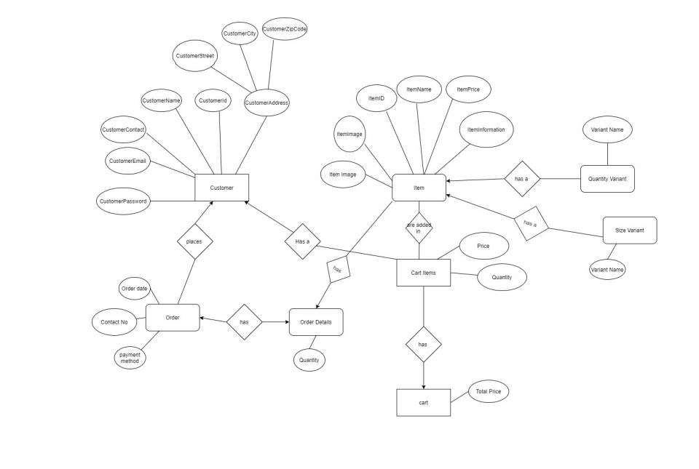

After this the Database is created and stored.

The Second Phase was mainly for the construction of project,

* + - Designing of the Login/Register Page.
    - Creation of all the functionalities required.
    - Designing of all other essential web pages to perform the desired functionalities properly.
    - Creation of Portal for Customers as well as the Database Administrator.
    - Added necessary options to the Portals.

After successful development of the portals for all the Users involved, and the functionalities required, we have added the required conditions in following steps:

* + - The User can see the products available on the website but cannot buy it without logging in to the website.
    - No two Categories/Products can have same name.
    - On Successful Delivery of Order/ Cancellation of Order, all its entries will be deleted from the tables for efficient use of space.

## Users Involved

### Administrator

* + - * Is redirected to Admin Page once logged in.
      * Can create categories for different types of products.
      * Can add Products in the Categories created.
      * Can see the total number of Users registered on the website.
      * Can see the analytics related to the orders done.

### Customers

* + - * Can register on the website and will get a User ID and Password for future login.
      * Can search for various products available, category-wise.
      * Can add products to Cart.
      * Can create an Order by successful check out, once all desired products are chosen.
      * Can cancel order anytime.
      * Can see his/her previous orders.

## Schema Design

### Introduction

Software is added for each of the functionality, and the schema design is involved in each of it. Each Schema of the website is briefly discussed here.

### Schema and Tables

#### Figure 1: All Tables

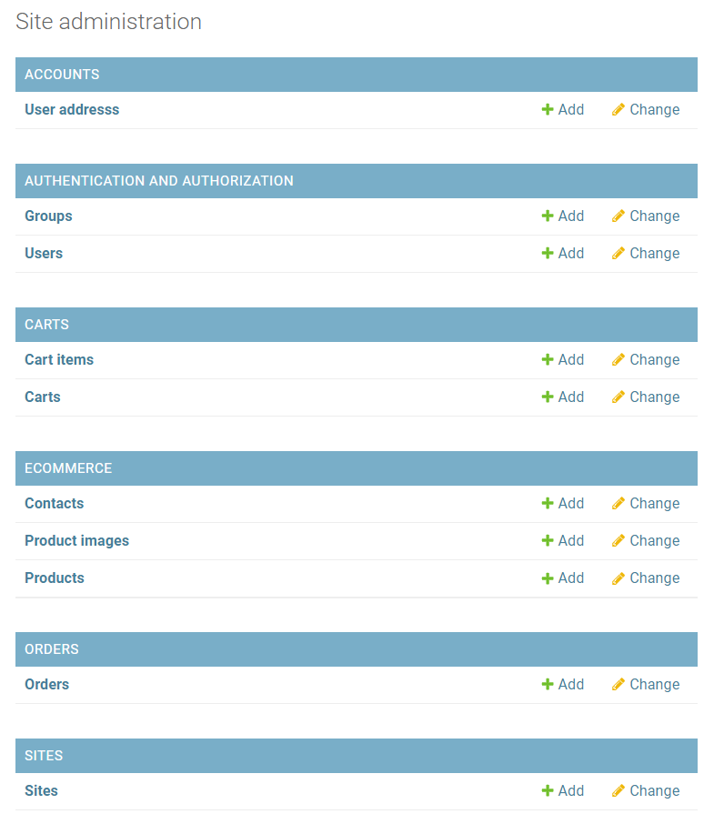

#### Figure 2: All Tables

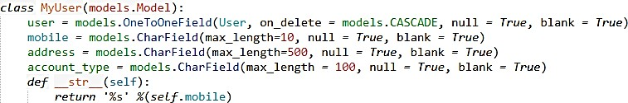

**Figure 3: Table to Store User’s Data**

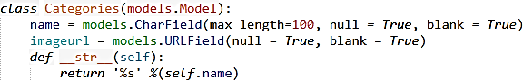

**Figure 4: Table to Store details of Categories**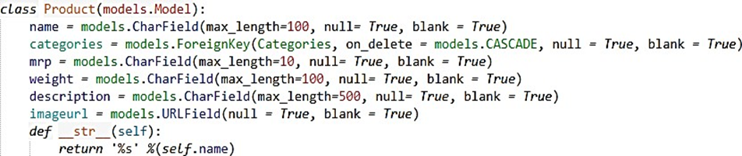

**Figure 5: Table to Store details of Products**

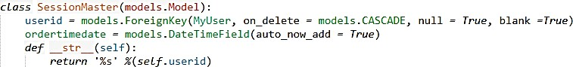

**Figure 6: Table to Store Records of Sessions**

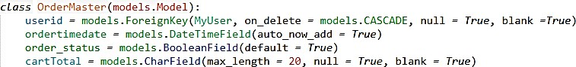

**Figure 7: Table to Store Order Records**

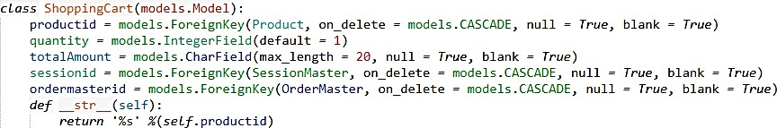

**Figure 8: Table to Store Details of a Shopping Cart**

* 1. **Project Architecture**

The steps involved in the whole projects are as follows:

### As a Customer:

* + - 1. The Customer will first need to login to buy products from website.
      2. Once the Customer enters his/her login detail, the detail will be matched with the database of Users.
         * If matched, the Customer will be logged in and redirected to homepage.
         * Otherwise, the Customer will get a message of either “No Account Found!” or “Invalid Username or Password!”.

If “No Account Found!” occurs, the Customer will have to register himself/herself on the website.

Otherwise, the Customer will have to give the valid ID and Password.

* + - 1. Once logged in, the Customer can go to different Categories as per his/her desire or can go to All Products page.
      2. The Customer can add desired products to Shopping Cart.
      3. Once he/she had added all the products, he/she can go to the Shopping Cart, where a Checkout Button is given.
      4. On pressing the Checkout Button, the Customer will be redirected to a webpage with the message, “Order Successfully Placed!”
      5. The Customer can see the Orders placed by him/her on the Account Page.
      6. The Customer can cancel his/her order anytime.

There is a portal for Database admin, which handles all the records of Customers.

### As an Administrator:

* + - 1. The Administrator is required to Login through the User Id and Password given to him/her.
      2. Once logged in, the Admin is redirected to the admin page which contains four blocks viz. Categories, Products, Users and Orders.
      3. The Admin can add/delete Categories if needed.
      4. The Products are added if needed.
      5. The Admin can only see the list of Users Registered and Orders done and has no right to Remove any User or Cancel any Order without asking the User.

## Technologies Used

### Introduction

Various front-end and back-end technologies are available in this era of digitalization. The technologies used in this project are discussed briefly in the following sections.

### Front-End Technologies

#### HTML

HTML**2** stands for **H**yper**t**ext **M**arkup **L**anguage, and it is the most widely used language to write Web Pages.

* + - * Hypertext refers to the way in which Web pages (HTML documents) are linked together. Thus, the link available on a webpage is called Hypertext.
      * As its name suggests, HTML is a Markup Language which means you use HTML to simply "mark-up" a text document with tags that tell a Web browser how to structure it to display.

Originally, HTML was developed with the intent of defining the structure of documents like headings, paragraphs, lists, and so forth to facilitate the sharing of scientific information between researchers. Now, HTML is being widely used to format web pages with the help of different tags available in HTML language.

#### CSS

CSS3 stands for **C**ascading **S**tyle **S**heets. CSS describes how HTML elements are to be displayed on screen, paper, or in other media. CSS saves a lot of work. It can control the layout of multiple web pages all at once.

#### JavaScript/JQuery

JavaScript (JS) is a [high level](https://en.wikipedia.org/wiki/High-level_programming_language), [interpreted](https://en.wikipedia.org/wiki/Interpreted_language) [programming language](https://en.wikipedia.org/wiki/Programming_language). JavaScript has [curly-bracket syntax,](https://en.wikipedia.org/wiki/List_of_programming_languages_by_type#Curly-bracket_languages) [dynamic typing,](https://en.wikipedia.org/wiki/Dynamic_programming_language) [prototype-based](https://en.wikipedia.org/wiki/Prototype-based_programming) [object-orientation](https://en.wikipedia.org/wiki/Object-oriented_programming), and [first-class functions](https://en.wikipedia.org/wiki/First-class_function).

Alongside [HTML](https://en.wikipedia.org/wiki/HTML) and [CSS](https://en.wikipedia.org/wiki/CSS), JavaScript is one of the core technologies of the [World Wide Web.](https://en.wikipedia.org/wiki/World_Wide_Web) 4 JavaScript enables interactive [web pages](https://en.wikipedia.org/wiki/Web_page) and is an essential part of [web applications](https://en.wikipedia.org/wiki/Web_application). The vast majority of [websites](https://en.wikipedia.org/wiki/Website) use it, and major [web browsers](https://en.wikipedia.org/wiki/Web_browser) have a dedicated [JavaScript engine](https://en.wikipedia.org/wiki/JavaScript_engine) to execute it.

As a multi-paradigm language, JavaScript [supports event-driven,](https://en.wikipedia.org/wiki/Event-driven_programming) [functional](https://en.wikipedia.org/wiki/Functional_programming) and [imperative](https://en.wikipedia.org/wiki/Imperative_programming) (including [object oriented](https://en.wikipedia.org/wiki/Object-oriented_programming) and [prototype-based](https://en.wikipedia.org/wiki/Prototype-based_programming)) [programming styles](https://en.wikipedia.org/wiki/Programming_paradigm).

It is important to validate the form submitted by the user because it can have inappropriate values. So, validation is must to authenticate user. JavaScript provides facility to validate the form on the client-side so data processing will be faster than server-side validation.

#### BootStrap

Bootstrap5 is a [free and open-source](https://en.wikipedia.org/wiki/Free_and_open-source) [CSS framework](https://en.wikipedia.org/wiki/CSS_framework) directed at responsive, mobile- first [front-end web development](https://en.wikipedia.org/wiki/Front-end_web_development). It contains [CSS](https://en.wikipedia.org/wiki/CSS) and (optionally) [JavaScript](https://en.wikipedia.org/wiki/JavaScript)-based design templates for [typography](https://en.wikipedia.org/wiki/Web_design#Typography), [forms](https://en.wikipedia.org/wiki/Form_(HTML)), [buttons](https://en.wikipedia.org/wiki/Button_(computing)#HTML), [navigation](https://en.wikipedia.org/wiki/Web_navigation#Local_website_navigation) and other interface components.

To use bootstrap, we are required to either install in our system or use CDN. CDN is short for content delivery network. A CDN is a system of distributes servers that deliver pages and other web content to a user, based on the geographic locations of the user, the origin of the webpage and the content delivery server.

### Back-End Technologies

3 HTML Styles-CSS, W3Schools.

4 Flanagan, David. JavaScript - The Definitive Guide (6 ed.). p. 1.

5 Bootstrap (front-end framework), Wikipedia.

#### Python

Python is an interpreted, high-level, general-purpose programming language. Created by Guido van Rossum and first released in 1991 6 , Python’s design philosophy emphasizes code readability with its notable use of significant whitespace. Its language constructs and object-oriented approach aims to help programmers write clear, logical code for small and large-scale projects.

In this website, python is used as backend language to code database part and all functionalities that the website can perform. Version of python used in this development is Python 3.6.

#### Django

Django is a high-level Python Web framework7 that encourages rapid development and clean, pragmatic design. Built by experienced developers, it takes care of much of the hassle of Web development, so we can focus on writing your app without needing to reinvent the wheel. It's free and open source. Django's primary goal is to ease the creation of complex, database-driven websites. The framework emphasizes [reusability](https://en.wikipedia.org/wiki/Reusability) and "pluggability" of components, less code; low coupling, rapid development, and the principle of [don't repeat yourself](https://en.wikipedia.org/wiki/Don%27t_repeat_yourself). Python is used throughout, even for settings files and data models. Django also provides an optional administrative [create, read, update and delete](https://en.wikipedia.org/wiki/Create%2C_read%2C_update_and_delete) interface that is generated dynamically through [introspection](https://en.wikipedia.org/wiki/Type_introspection) and configured via admin models. Version of Django used during development is Django 2.1.5.

#### SQLite

SQLite is a C-language library that implements a small, fast, self-contained, high- reliability, full-featured, SQL database engine. SQLite is the most used database engine in the world. By default, Django used SQLite3 as its default database. Django provides specific way to define our database using the python programming language.

# Chapter 4

**RESULTS AND ANALYSIS**

## Introduction

In this Chapter, a brief discussion about the System Specifications as well as the UI is done with the functionalities related to them. At last of the Chapter, the advantages as well as the disadvantages of the system developed has been discussed.

### System Specifications

* + - Processor: Intel(R) Core(TM) ie-5005U CPU @ 2.00GHz processor
    - RAM: 2 GB
    - System Type: 64-bit operating system, x64-based processor
    - Operating System: Windows 7/8/10.

### Software Interface

* + - Front End: HTML, CSS, Bootstrap, jQuery
    - Backend: Django
    - Local Access Link: localhost:8000

## Performance Metrics

Performance of the software is measured on following performance metrics8:

#### Availability

Availability of a system is measured as a factor of its reliability, as reliability increases, so does availability. The system developed remains operational under all circumstances. Hence, it is highly reliable and readily available in any condition.

#### Response Time

Response time is the time taken between requesting for a service and receiving first output. As the database is stored online, the retrieval of information is fast and hence the response time is less.

#### Processing Speed

Processing speed of the system depends on the processor specifications. The processor in my case is Intel® Core™ i5 CPU M560 @2.67 GHz.

#### Throughput

Throughput is the rate at which output is produced i.e. output per unit time.

#### Scalability

Scalability of a system is its ability to manage growing amount of work properly without degrading its performance.

#### Compression Ratio

Compression is considered as important performance metric as it helps us to utilize the resources efficiently by reducing its usage such as space for data storage. Since the stored data by the system may be high and become even higher for larger problem sizes, data compression and decompression later would be best applicable in this case.

## Advantages

* Fast and Easy Service.
* Time saving.
* Online Database, thus Faster Access.
* Working Load Reduced.
* Simple User Interface.
* 24/7 Potential Income.
* Secured Data.
* Low Cost.
* Storage-Friendly.
* Reliable.

## Limitations

* + - We can make this project more user-friendly and work on UI/UX for better view of the web application.
    - There is no Status Information of the Order provided on the website. It will be done manually by SMS/Email by the Admin.
    - Order once cancelled will be removed totally from database, to save space but, the Customer will be unable to see it in his/her history.

## Some Snapshots

* + 1. **Home page**

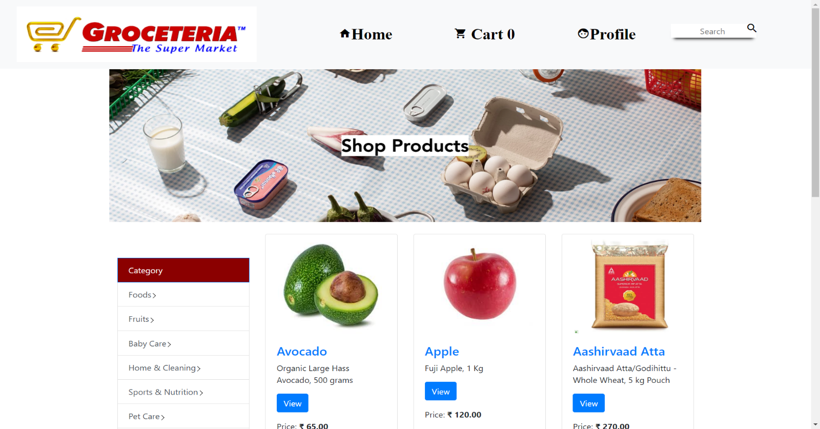

* + 1. **Shop page**

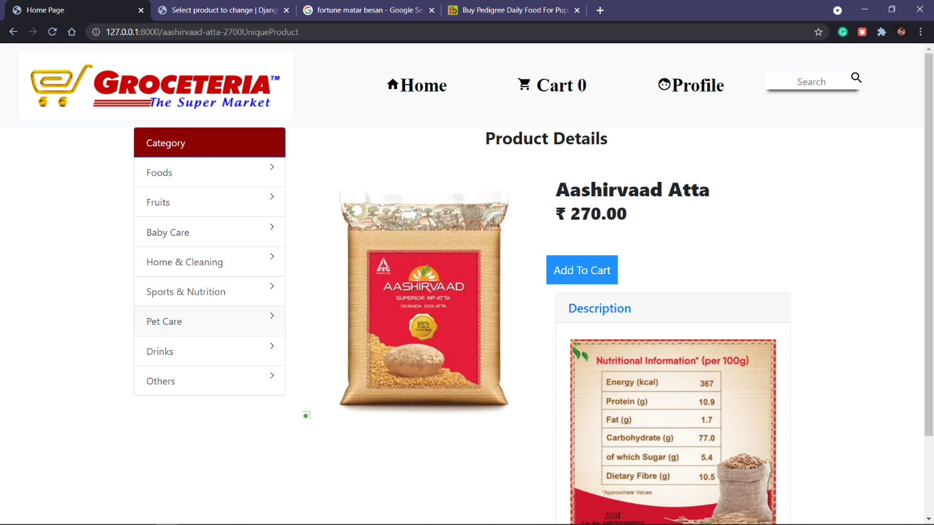

* + 1. **Login and Register**

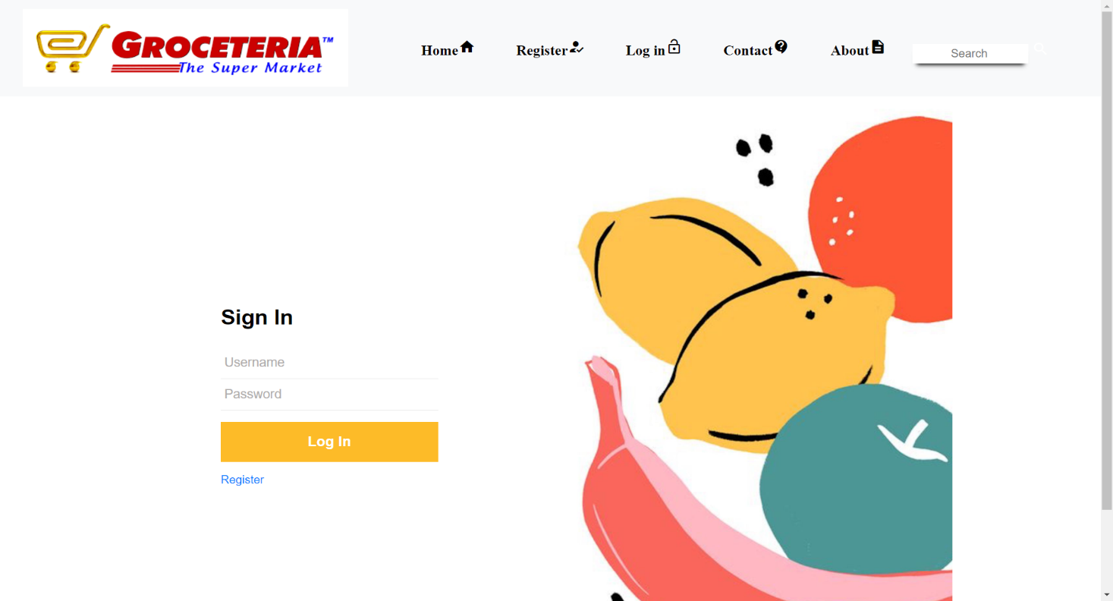

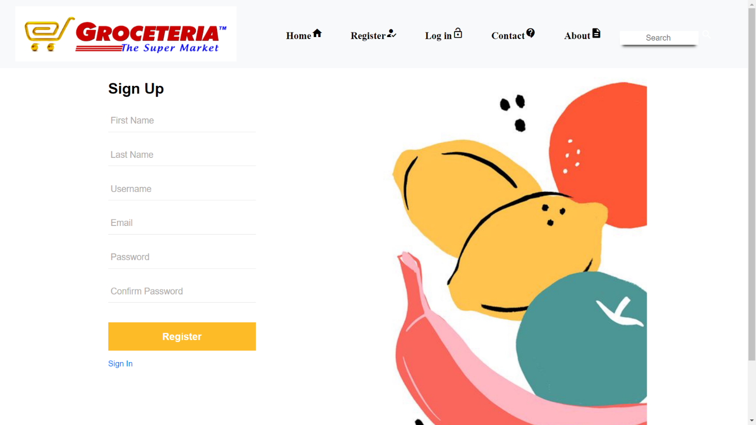

* + 1. **Checkout page**

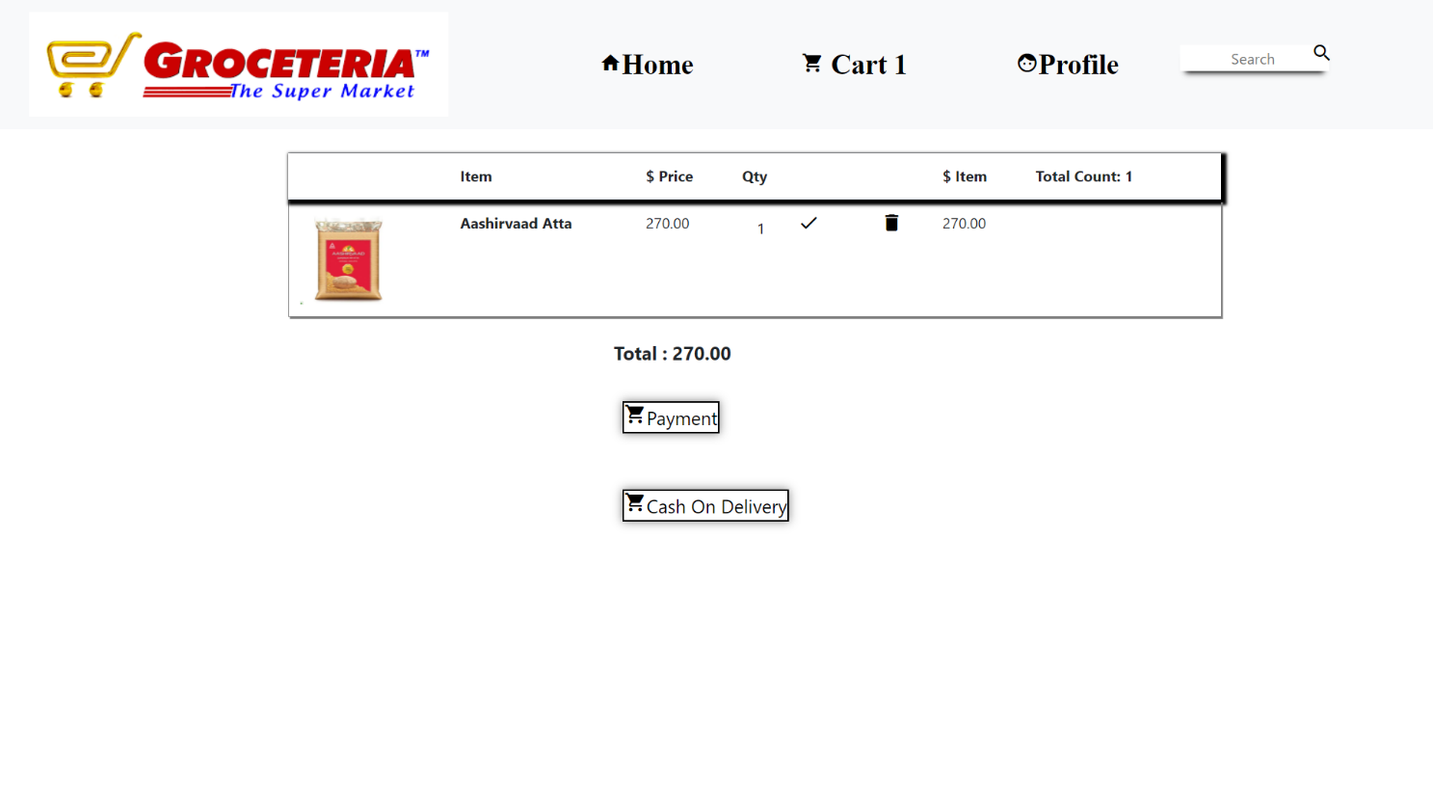

* + 1. **Home Page before login**

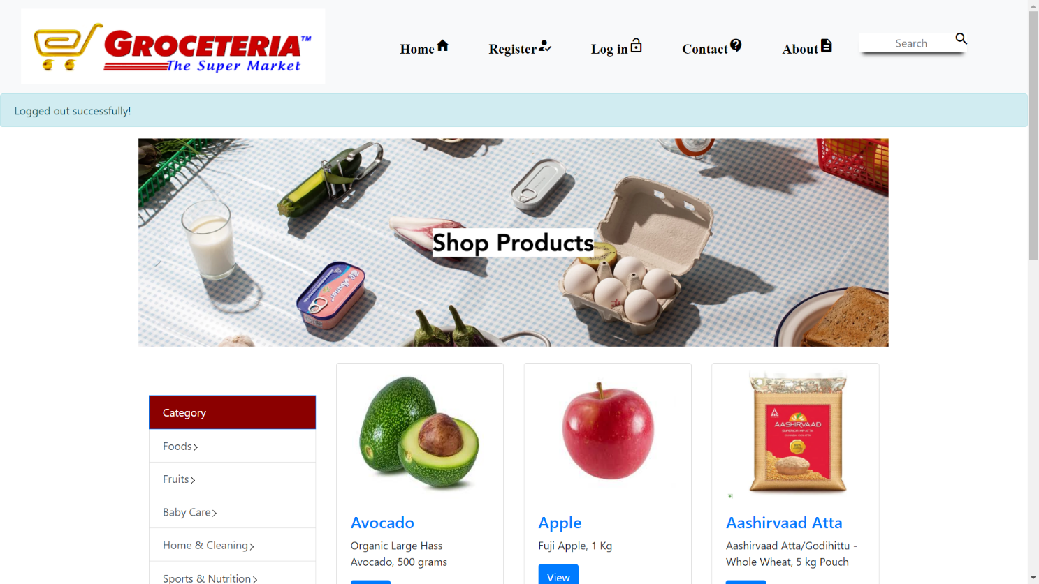

**Chapter 5**

**SUMMARY AND CONCLUSIONS**

* 1. **Summary**

“The FOLCART Website” is an online marketing technique to be used by any normal people for selling their products. The users of this system are general civilians. The Database is maintained completely by the Administrator in which the complete detail of Users registered is stored.

There are two types of Users viz. Customer and Administrator. The Customer can login by his/her username and password and can place orders as per his/her requirement. The Customers can also view their personal details and previous orders through their respective account page. Details of the orders placed are stored on the database safely. Once the order is cancelled, it is removed from the database for proper utilization of storage. The Administrator can login by the username and password provided and on login is redirected to the main admin page which shows the whole database.

This project meets the requirements and justifies the purpose for which it is built. The system has reached a steady state where most of the bugs are eliminated. The User Interface is simple and easily understandable to any User.

The system is operated at a high level of efficiency and all the users associated with the system understand its advantage. The system solves the problem it was intended to solve at the time of requirement specification. Efficient utilization of storage is done.

## Future Works

* + - Use of OTP at the time of Login/Registration can be done for further security of User Data and to tackle invalid details like Mobile No. or Email.
    - Various different payment methods can be used via Third Party Sources (Payment Gateways).
    - The Order Status section can be introduced to further simplify the whole process for Customers as well as Database Administrator.
    - Cancellation History Section can be developed further for Customers so that they can have a separate history of the orders cancelled by them.
    - Various Sorting and Filter Techniques can be further introduced for easier searching of desired products.
    - Improvements in visualization and compatibility can be further done.
    - By changing some of the features, this project can also be used as an E Commercial Website for any other Company, hence optimizing the time of development of another project.

## Conclusion

All the requirements specified by me are met as well as few more features are added in the system. Use of Online Database and modern development techniques had led to a system with Proper Utilization of Space and Time. And the simpler UI of system helps the customers to easily navigate through the site. Maximum bugs are removed from the system. If required various features can be added further easily as the code is easier to understand by any developer.

**REFERENCES**

* + - Navathe, Elmasri, Somayajulu, Gupta, Fundamentals of Database Systems, Pearson Education.
    - Pankaj Jalote, (2003), “An Integrated Approach towards Software Engineering”, Narosa Publishing House.
    - [HTML](https://www.tutorialspoint.com/html/html_overview.htm) Overview, TutorialsPoint.
    - HTML Styles-CSS, W3Schools.
    - Flanagan, David. JavaScript - The Definitive Guide (6 ed.). p. 1.
    - Bootstrap (front-end framework), Wikipedia.
    - Kuhlman, Dave, "A Python Book: Beginning Python, Advanced Python, and Python Exercises", Section 1.1.
    - Django Homepage, DjangoProject.
    - Pankaj Jalote, (2003), “An Integrated Approach towards Software Engineering”, Narosa Publishing House.